CS-325: Software Engineering

Assignment: Software Design Specification

Uni-Verse Application



Group Members:

Ahmad Hasan (2019041)

Taimoor Ahmad (201511)

Sauman Arshad (2019363)

Muteeb Ur Rehman (2019419)

Table of Contents

Project Design/Architecture: 2

Use Case View 2

Use Case-1: Uni-Verse – User Management 2

Use Case-2: Uni-Verse – Post Management 3

Logical View 3

Class Diagram: 3

Deployment View 4

Component Diagram: 4

Process View 4

AC-1: 4

Physical View 5

Sequence Diagram 5

User Interface 6

Sign-Up and Log-in Screen: 6

Screen-1: 7

Screen-2: 8

Screen-3: 9

# Project Design/Architecture:

## Use Case View

### Use Case-1: Uni-Verse – User Management

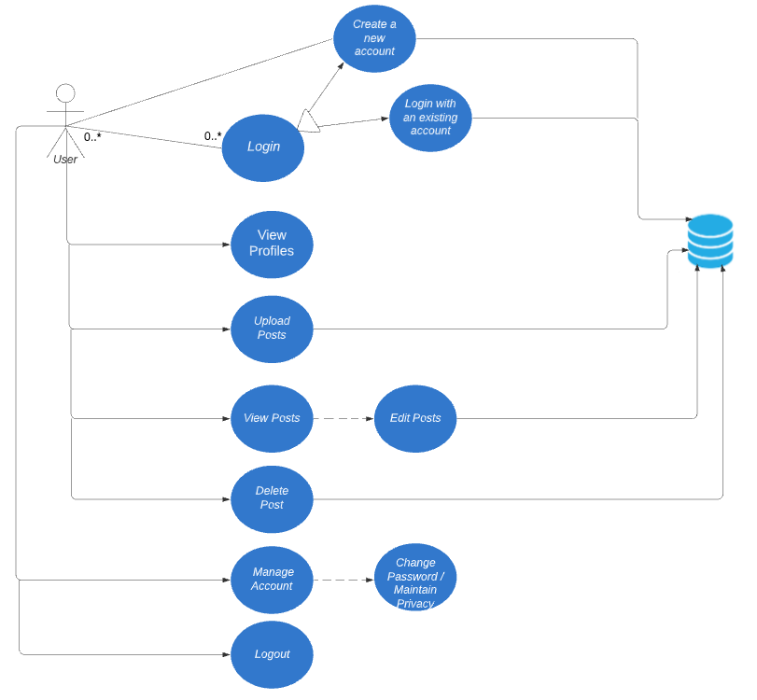

### Use Case-2: Uni-Verse – Post Management

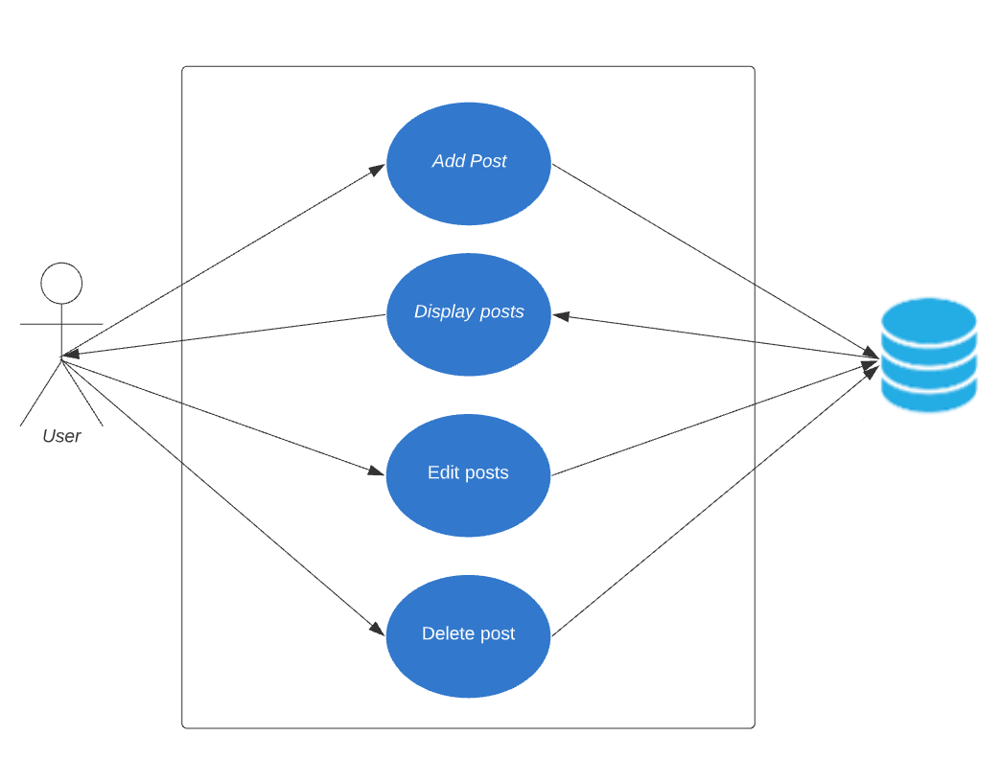

## Logical View

### Class Diagram:

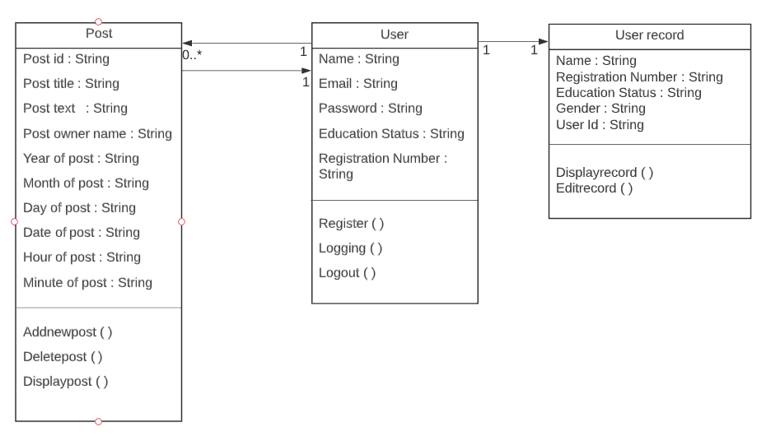

## Deployment View

### Component Diagram:

## Process View

### AC-1:

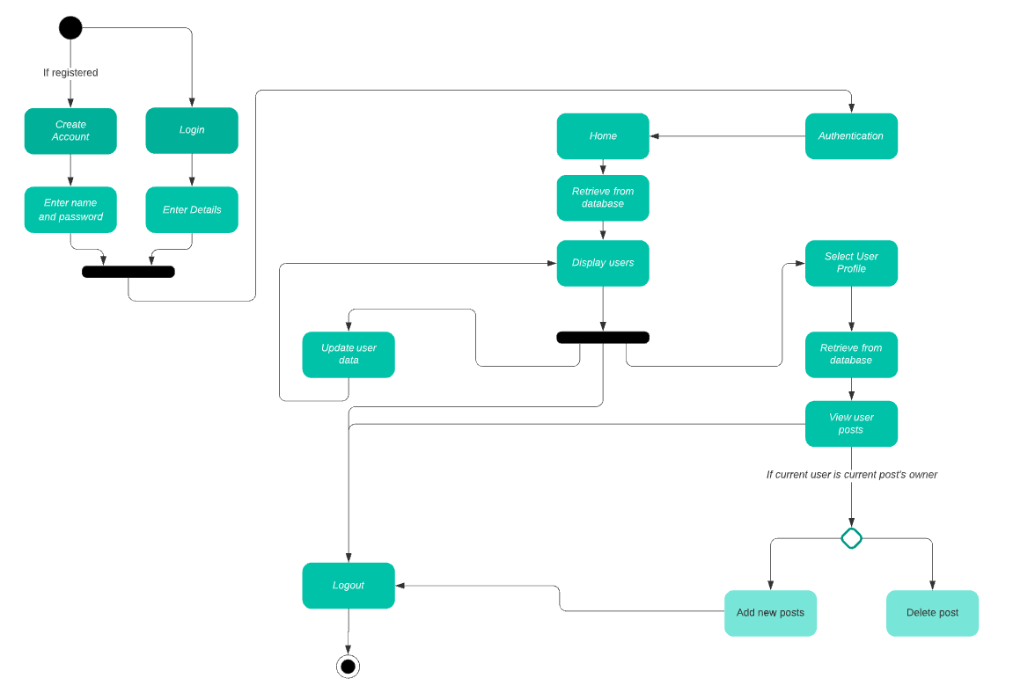

## Physical View

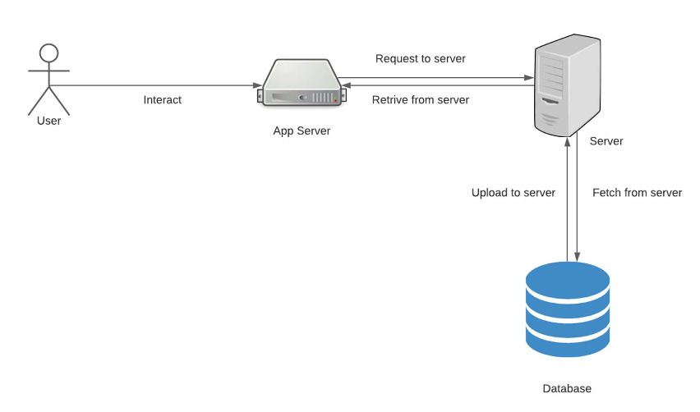

## Sequence Diagram

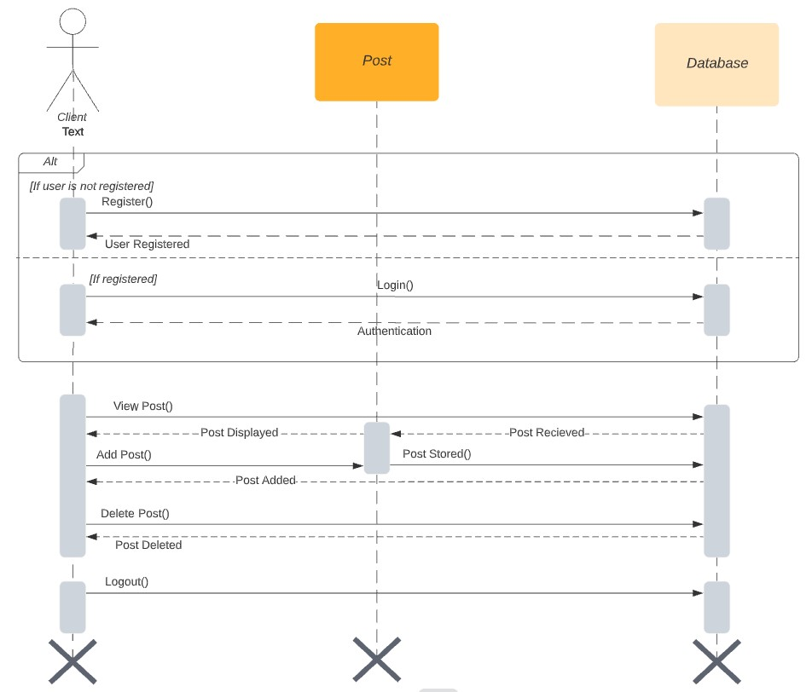

## User Interface

### Sign-Up and Log-in Screen:

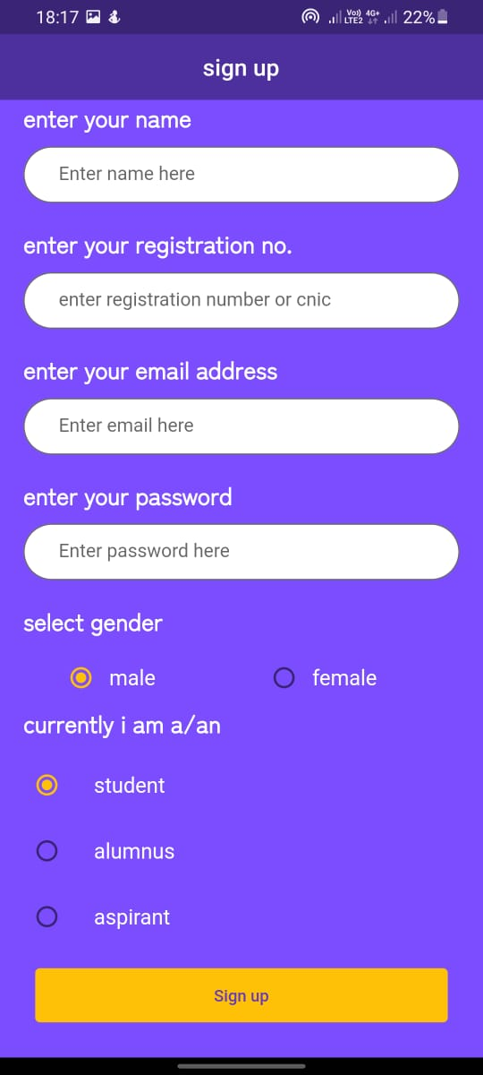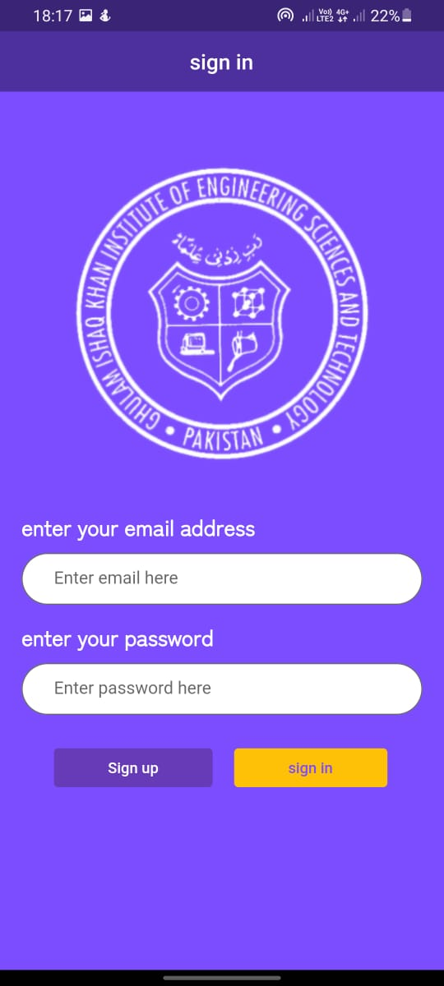

### Screen-1:

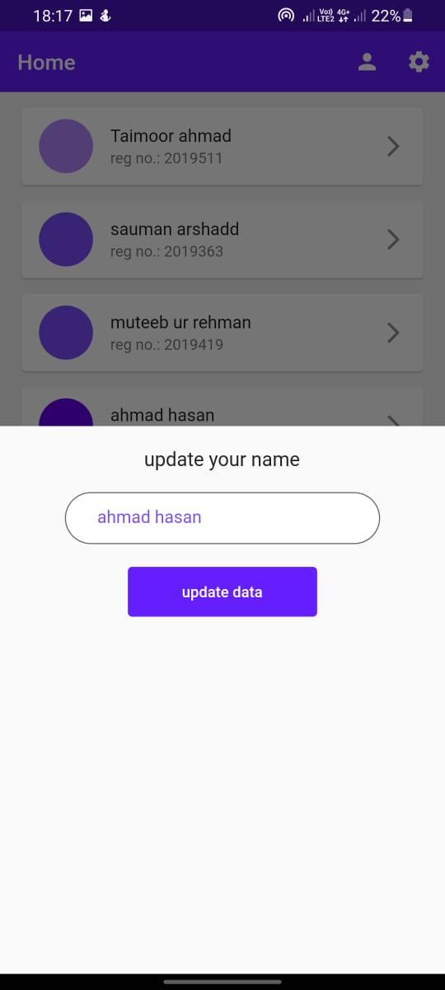

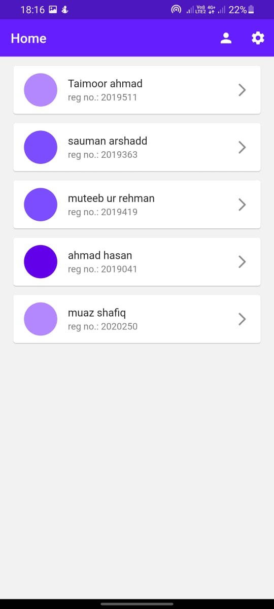

### Screen-2:

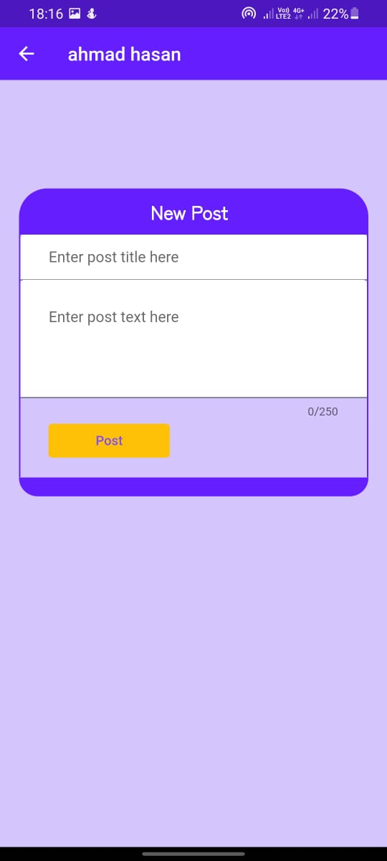

### Screen-3:

